Prototype 2 Report

At this stage, the game is not as further along as I had hoped, but the target game is nearly complete. After it is finished, I will have most of the code I will need to complete the other minigames. I’ll need to work faster next term, but I should have the project done in time if I do.

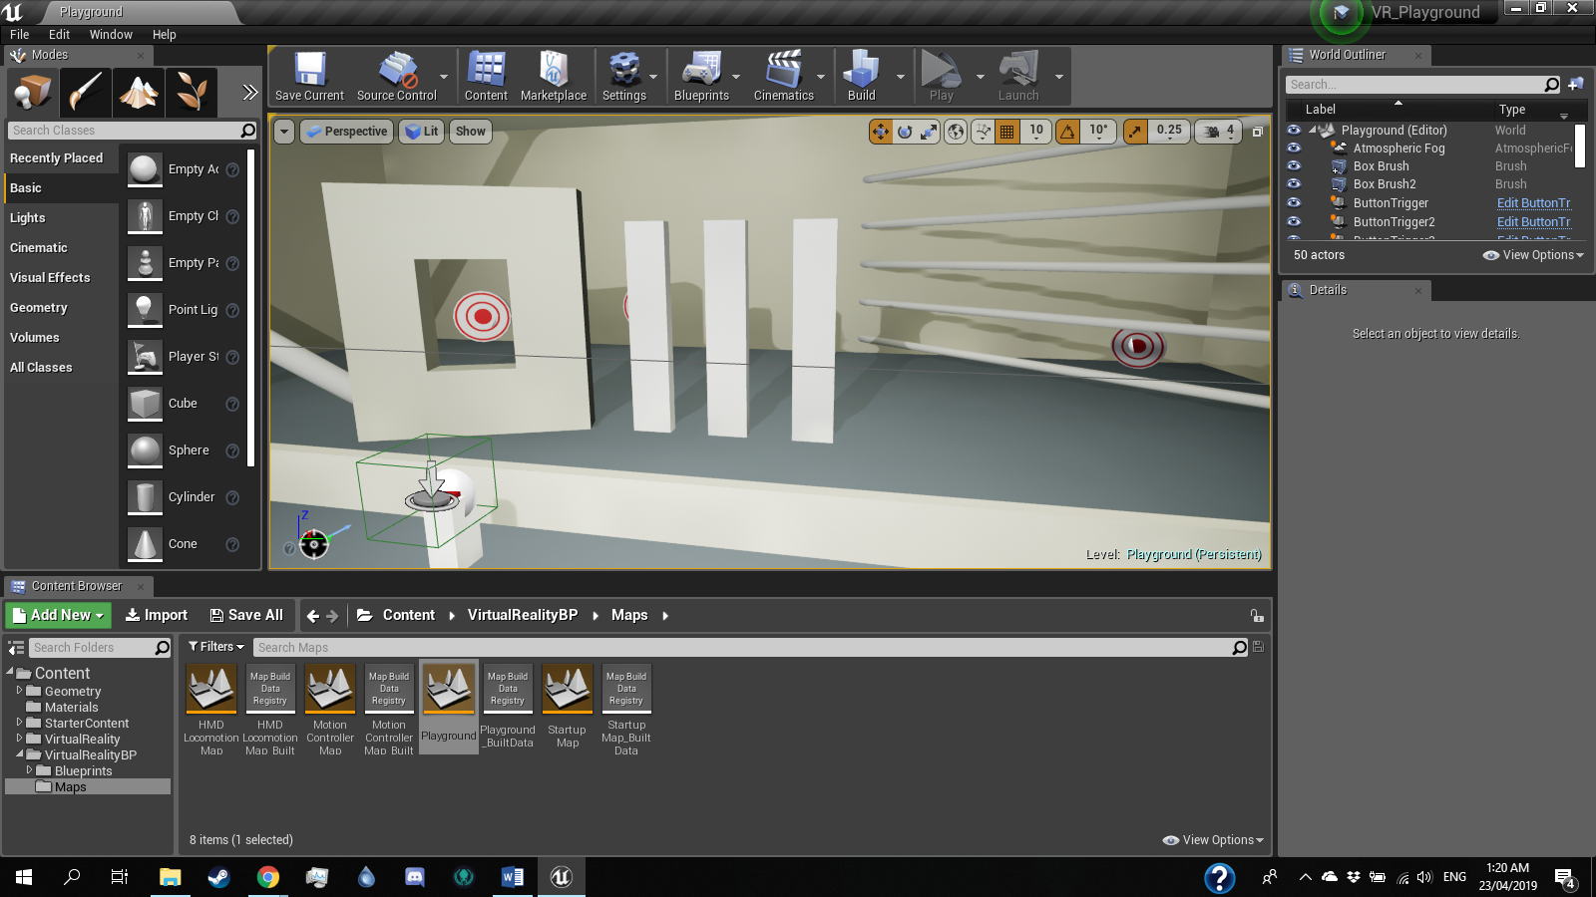Level

The target game is almost done, and for now the other games are still as planned, for the target game I just need to set up the collision event that will add points, and the timer. Much of the code for the target game will be used for the other minigames, which will save a lot of time.